Mind & Muscle

The Ultimate Team Challenge in VR

**Preview:**

**• The idea.**

**• Scope Motivation**

**• Sketches**

**• Implementation**

**• Scenes**

**• Feasibility and Challenges**

**• Testing and Evaluation**

**• Survey**

**• Conclusion**

The idea:

The idea came from the TV show ‘Takeshi's Castle’ but with a twist. Takeshi's Castle only allowed winners but hurdles could have been made easier if there was a group of people competing and everyone got a chance to play their strength. This is where the idea came from, and to make things more interesting we added puzzles so that players feel more challenged.

The game begins by asking how many members are competing in a team. The rules are simple: Those with the most points win. The competing team decides whether to participate in the physical or mental course.  
  
In short, it is the ultimate team challenge. The upcoming challenge will be displayed on a screen. Each team will have 2 minutes to select a team member or members to participate. Every challenge can have variable time lasting from 45 seconds to 10 minutes. Time can vary according to each challenge. Bonuses and penalties will be awarded throughout each challenge based on specific criteria according to the specific game.  
  
 There can be plenty of mental games such as Think Tank, Guess the Word, and Memory Mayhem. difficulty of each game can depend on the number of team players participating and the round. Physical games can also be varied and will be shuffled according to the difficulty of rounds. For the physical course, all participating members must have to act, but in puzzle games, players can often have a choice to play as a group.   
  
Physical games can vary from virtual archery, darts, skipping stones, fruit ninjas to many more. Penalties will take effect if members fail to accomplish a task or take a wrong action according to rules. Bonuses will be hidden across each lap to make up for the loss. After 2 rounds the team with the lowest score will be eliminated.

Scope Motivation:

There are several games online that either challenge your physical capabilities such as Party Pie or your mental capabilities such as Puzzling Places but not much out there that can challenge both. We created Mind & Muscle VR to push the boundaries of entertainment and challenge. Our VR experience aims to break this mold, offering an exhilarating fusion of mental acuity and physical prowess. Our motivation is simple: to redefine what it means to play and to inspire players to unlock their full potential, one challenge at a time.  
  
In most games, one has to master a skill to be great, but in our ultimate challenge people with multiple skills compete with one another. So one doesn't have to learn everything but compete as a team and have fun. It breaks traditional training like you do not need too much physical stamina to compete, no injuries, and no need to create a space but have it exist virtually. The competing teams don’t even need to be in the place to have fun and challenge.

Sketches:

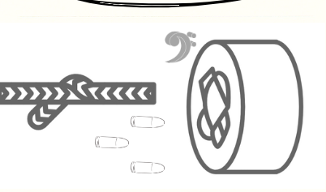

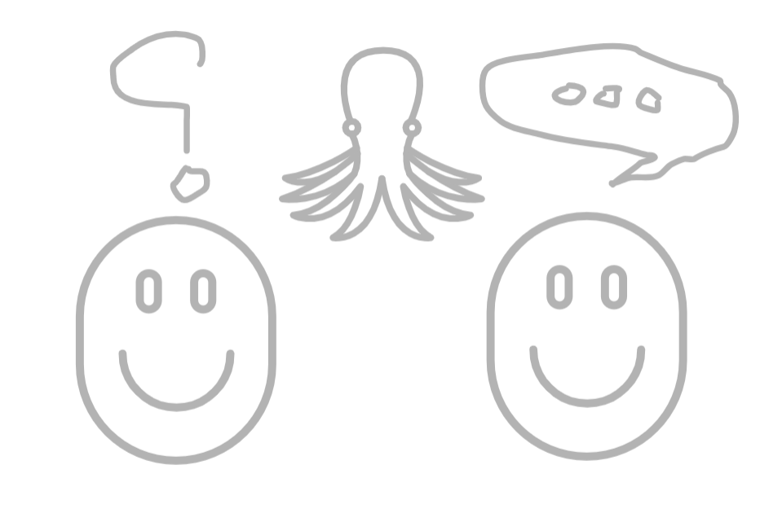



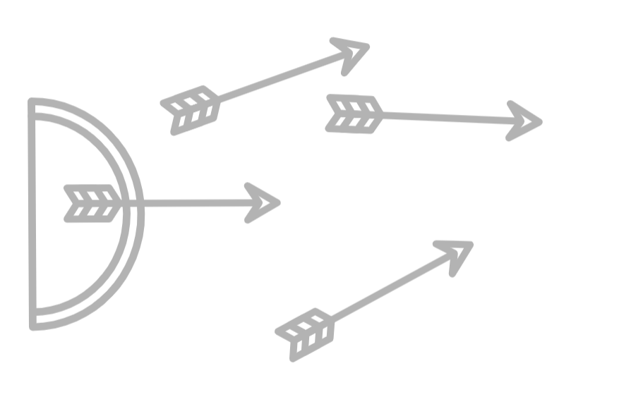

Phase 2 - Implementation:

**Onedrive link:**

<https://drive.google.com/file/d/17EsjigQQtGYLZ54-FtMd-Uh4BE8kVrTH/view?usp=drive_link>

**Brief description of the implementation:**

As discussed in scope there will be a main menu and a screen where the completing screen will choose the number of team members. Then they will decide on which challenge to take. If the take on the puzzle challenge the main goal is to solve it before the timer runs out. Wrong guesses can lead to a penalty. If they decide to take the physical hurdle then they must acquire as many points as possible in a given set of time. Bonuses can be awarded to teams acquiring specific conditions (such as hitting bonus targets or finding unique items) and penalties in case a team member fails to achieve the task.

**Added Feature - Sound:**

Sounds are added to the game to keep the user experience more interactive and engaging.

**Game Stages:**

More stages and games can be added so users can have more variety of games to play and increase the number of victory rounds. We can also add bonus rounds with more strict rules for teams who are close to elimination.

**Unreal Engine:**



We used **Unreal Engine 5.3** with the **Unreal Engine’s OpenXR plugin** to create the levels. OpenXR is an open **standard API** designed to simplify VR and AR development. It acts as a middle layer between the application and the runtime provided by the specific VR/AR hardware (like Oculus or HTC Vive). This means we can write code that interacts with the OpenXR API, and that code will work seamlessly across different devices as long as they have a compatible OpenXR runtime.

The Unreal Engine OpenXR plugin also makes VR development for existing 3D projects much easier. Since some of our environmental objects were in 3D it helped us covert and streamline the core functionalities needed for VR experiences. It saved us a lot of time during testing (can run on any PC) and we didn't have to worry about the compatibility of our 3D assets.  
  
 Most materials are from the **UE** **Starter pack** while some metallic textures were imported from the **UE Marketplace** and **Qixxel Bridge**.

**Blender:**

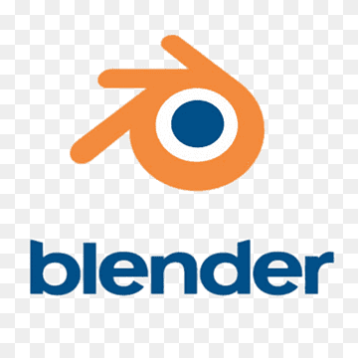

The targets in the shooting level were modeled in a blender. Blender is a powerful tool for modeling 3D assets.

**Canva:**

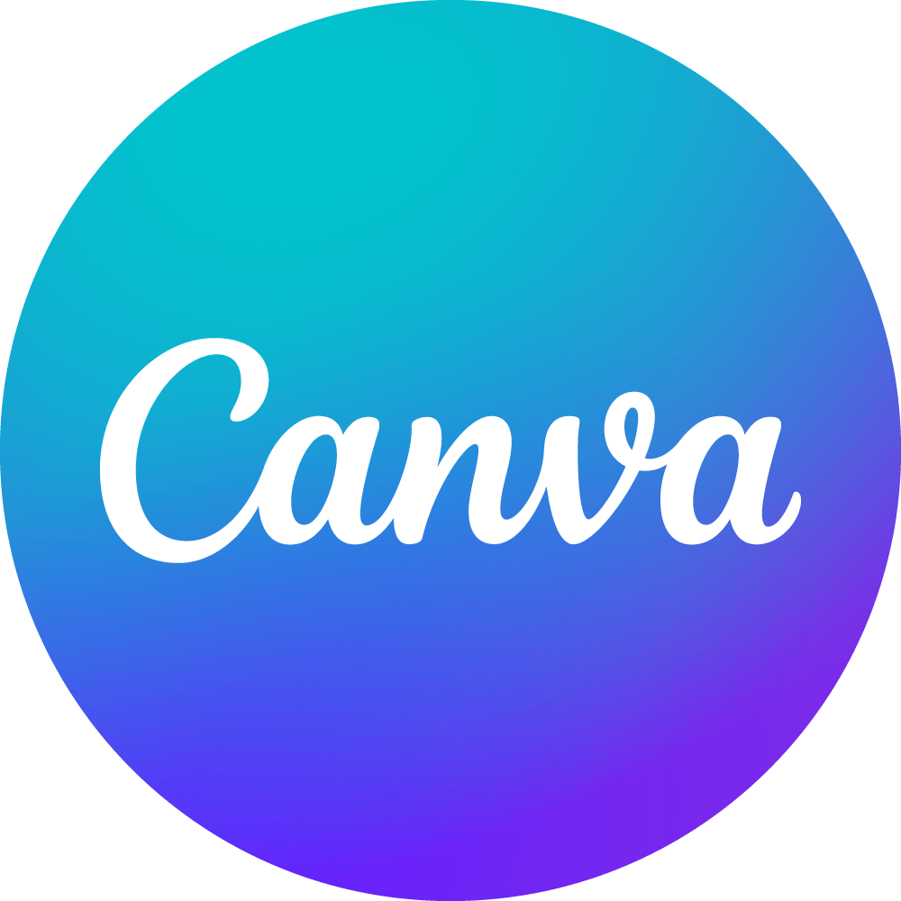

The menu images were designed in Canva. Canva is an online tool for wireframing and graphic designing.

Scenes:

* **Main Menu**



* **Team Selection menu**



* **Select Challange**

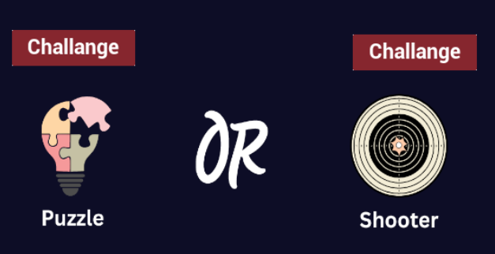

* **Puzzle Game Scene**

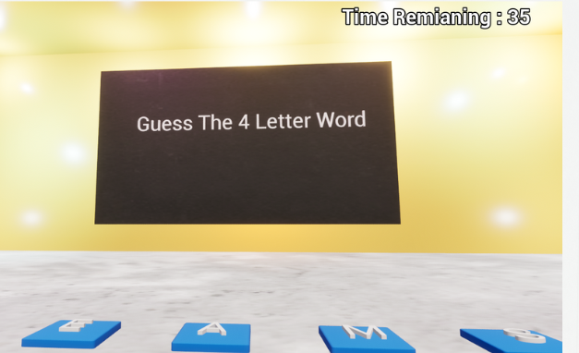

* **Physical Game Scene:**

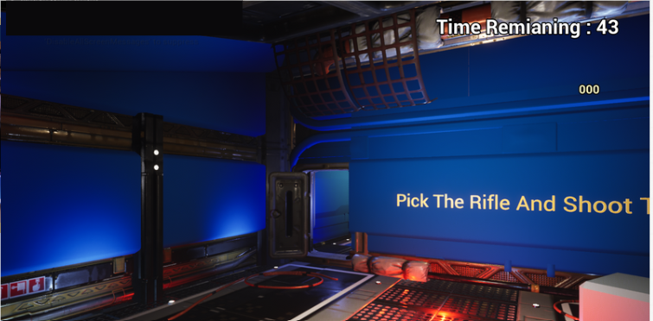

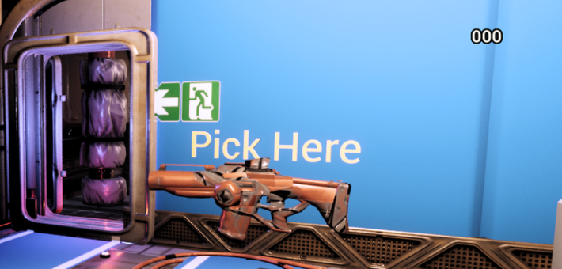

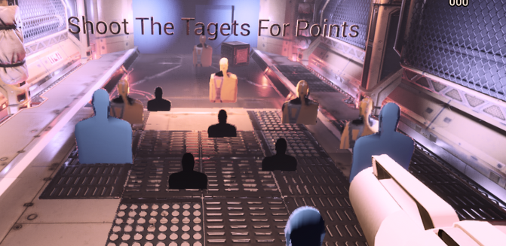

How to Play:

**Puzzle Game:**

Players walk around the VR space and physically step on tiles with letters. Each tile will make a sound as they step on it, building the word they're creating.

* The team that guesses the word first, in the given time wins.
* If the player enters the incorrect word the tiles reset.

**Shooting Game:**

Players connect and form teams of two or solo depending upon difficulty and audience.

* Grabbing the Gear: Each player equips a virtual rifle and enters the VR shooting arena.
* Target Identification: Scan the environment to locate targets scattered around the map. Every target has different points. Bonus targets will appear on the map after some time.
* Win Condition: The team with the most points when the timer runs out, wins.

For all games, the difficulty, accuracy, team, and time are in the hands of the developer. (in order to collect data according to user experience) The users don’t get to select what difficulty to play.

Feasibility and Challenges:

The main challenge was setting up the scene and properly lighting using Unreal Engine. After a lot of trial and error and the maximum effort to reduce the project size we only used starter content and built-in materials of Unreal. The toughest part was to make the mesh for the shooter game in Blender. Making sure they had a proper shape.  
  
Then the challenge was to animate them and to make sure to accumulate points when the bullets hit them. All the moving targets had different speeds, points of accumulation (bonus), and areas of animation.  
  
This is how they were programmed using blueprints  
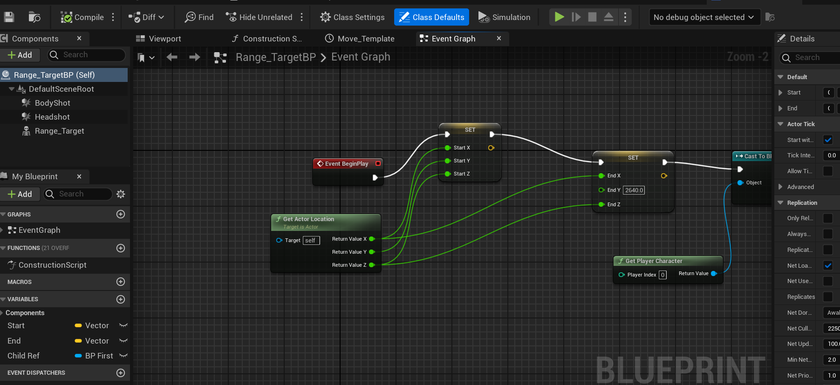

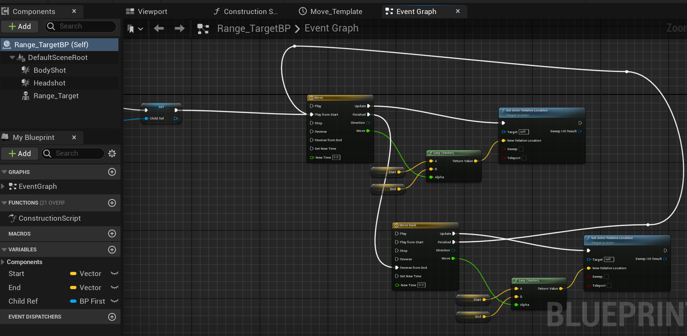

Then the next hurdle was to make the skipping tiles and store the correct word in order. Here is how they were made:  
  
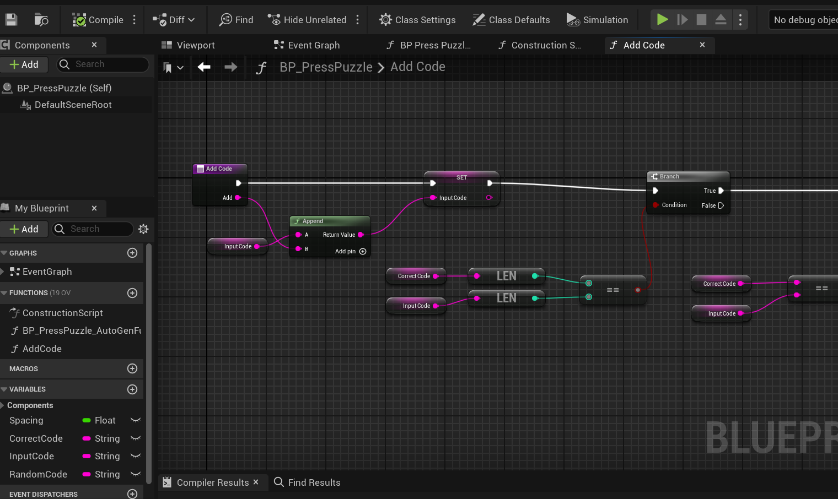

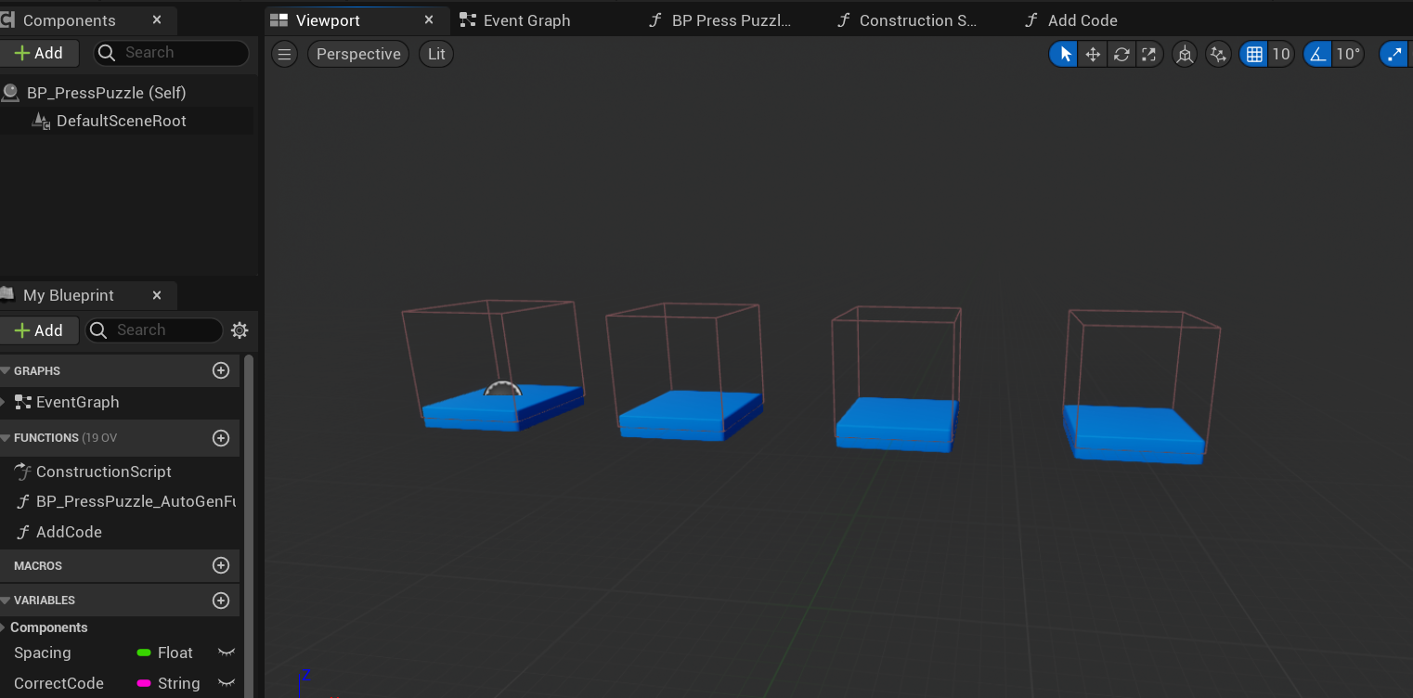

The number of tiles depends on the letters of the guessing word.

Both scenes had lighting issues at the start, but somehow we were able to add elevating colors to the scene so that users found them aesthetically pleasing and 3D instructions so that they could navigate easily.  
  
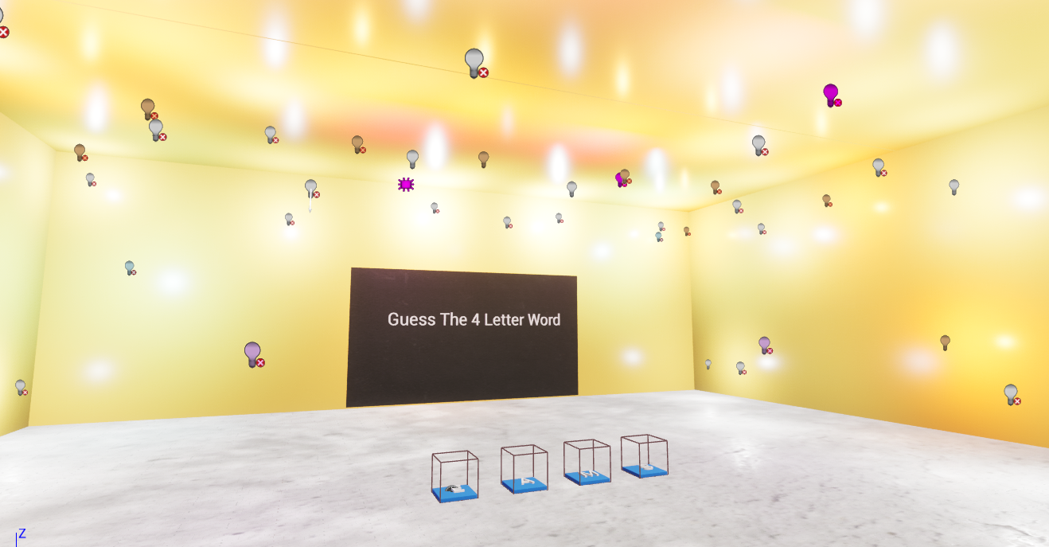  
  
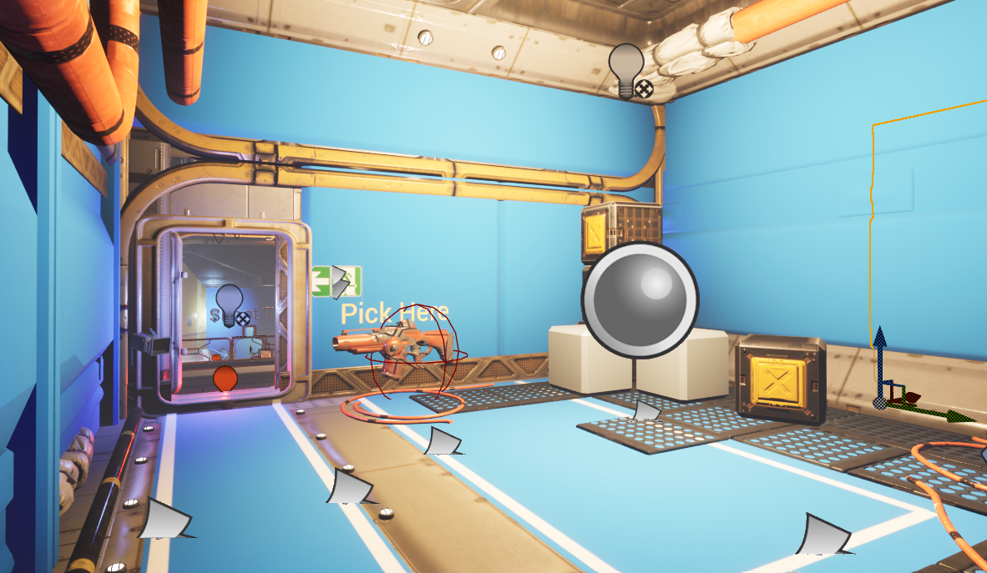

Phase 3- testing and evaluation:  
Interviews

**Participant 1:**

"Mind & Muscle VR? Oh, it's like Fall Guys, but with a puzzle twist! You've got these two levels—shooting for points and cracking word puzzles—that keep you on your toes. It took me a few attempts to even guess that 4 letter word. The scenes are so vibrant, I loved the shooting arena. Navigating was easy with those 3D text guides. The menus are straightforward, too, so you can focus on the action. Playing this? It's like stepping into a wild, puzzle-filled adventure!"

**Participant 2:**

"Mind & Muscle VR blew me away! They've got two epic challenges: one where you're shooting for points and another where you're cracking word puzzles. Talk about keeping your brain and body in top gear! Having to compete in teams is a smart move because there aren’t many VR games that allow such team-arena experiences. Also, the sound effects were amazing, they brought back some old arcade memories from childhood.  
  
**Feedbacks:**  
  
Mind and muscle can be evolutionary in terms of team challenges. We can add paint wars, wall skipping, virtual shogi and many more just to bring people closer but in VR. Our game in VR stands as a testament to the team's dedication to crafting an immersive and thrilling experience. The game offers a dynamic range of challenges and interactive virtual space. Through innovative gameplay and strategic design, our VR platform provides a unique avenue for individuals to not only engage in exhilarating competition but also to foster teamwork to win. As highlighted by the second participant, his mentioning of team games as a smart move by the team suggests that people are willing to play team games. In the upcoming future people will no longer travel to meet friends or family but be using virtual spaces. Having more multiplayer team games will allow people to spend quality time together.  
  
We can bring a virtual arcade experience to life from people's childhoods where they as kids used to get together in shops just to have thrilling experiences and entertainment.

Survey:  
  
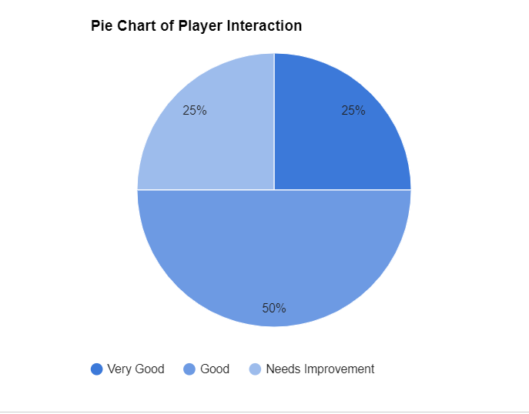

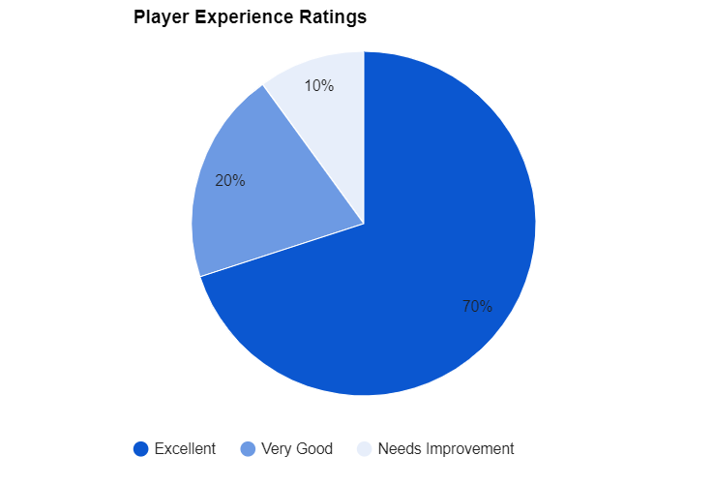

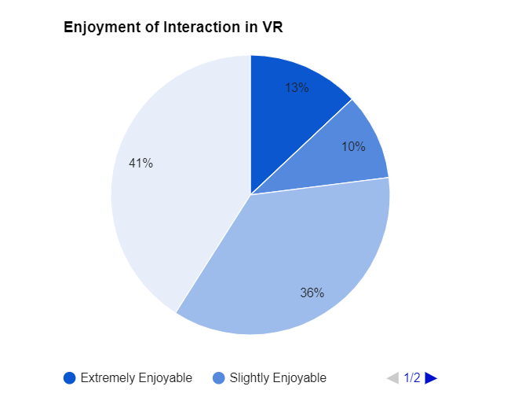



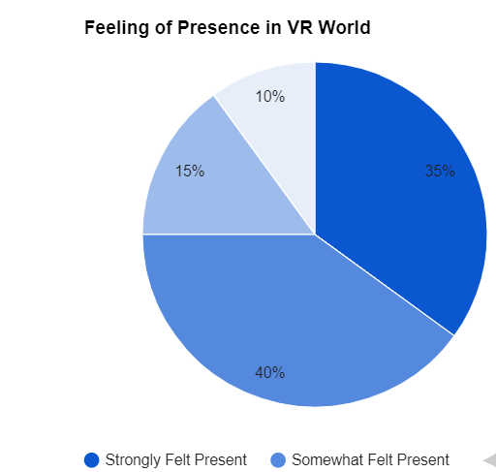

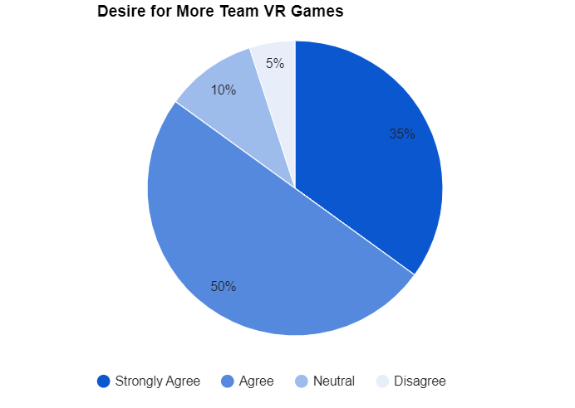

Conclusion:

Based on what we were aiming for In conclusion, Mind & Muscle VR stands as a testament to the team's dedication to crafting an immersive and thrilling experience was successful. The game offers a dynamic range of challenges and interactive space where players can test their limits and unleash their logic and mental capability as well as their physical skills. Through innovative gameplay and strategic design, our VR platform provides a unique avenue for individuals to not only engage in exhilarating competition but also to foster teamwork, allowing users to spend quality time and entertain themselves.